**WEEK – 3 Assignments**

**Entity Framework Core 8. 0**

**Mandatory hands-on :-**

**Lab 3: Using EF Core CLI to Create and Apply Migrations**

**Scenario:**

The retail store's database needs to be created based on the models you've defined.

You’ll use EF Core CLI to generate and apply migrations.

**Objective:**

Learn how to use EF Core CLI to manage database schema changes.

**1. Install EF Core CLI (if not already)**

| **dotnet tool install --globai dotnet-ef** |
| --- |

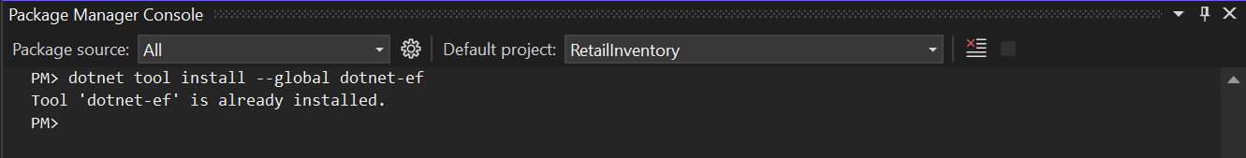

**2. Create Initial Migration**

| dotnet ef migrations add InitialCreate |
| --- |

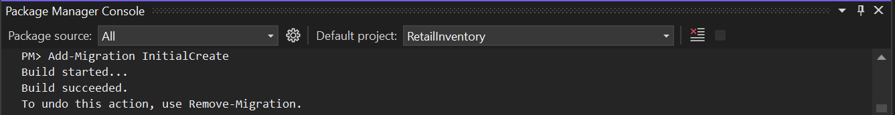

**3. Apply Migration to Create Database:**

| **dotnet ef database update** |
| --- |

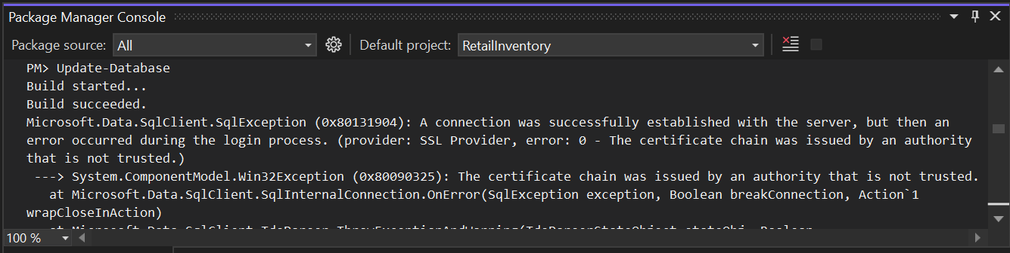

**4. Verify in SQL Server:**

